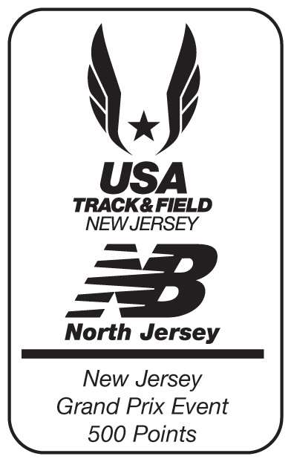


Bring your old sneakers to the race to recycle them for Nike Reuse-A-Shoe.

Please recycle !



Shepherd Lake is located at 12 Morris Road in Ringwood, NJ. It is easily accessible from Routes 287, 17, and 208. For DIRECTIONS see our website at www.RingwoodEF.org.

IT’S CLOSER THAN YOU THINK!

Shepherd Lake 5K

sponsored by the

Ringwood Educational
Foundation, Inc.
at the
Ringwood State Park
Ringwood, NJ



* Shepherd Lake 5K tech shirt
* B-Tag Chip Timing
* Scenic, Country Course
* Raffles & Prizes

Saturday, May 14, 2011

1 Mile Kids Race 8:30 am
1 Mile Walk 8:45 am
Kids Dashes 9:00 am
5K Run 9:30 am

11th Annual Shepherd Lake 5K

7:30 Registration Begins Rain or Shine
8:30 1 Mile Kids Cross Country Race
8:45 1 Mile Walk
9:00 Kids Dashes
9:30 5K Run
Award Ceremony Immediately Following

Registration:
By mail: P.O. Box 297, Ringwood, NJ 07456
Online at: www.raceforum.com/shepherd or
http://www.active.com/event_detail.cfm?event_id=1900588
Download application at www.RingwoodEF.org For further information call Luis at 201-741-3251
E-mail ShepherdLake5K@yahoo.com

Info: Parking, Indoor Registration and Start & Finish Line located at Shepherd Lake
Tech T-shirt guaranteed for all 5K pre-registered
Entry Fees:
5K Run .......................................$25 ($30 Race Day)
5K Run with USATF # ...............$23 ($30 Race Day)

1 Mile (14 & under) Kids Race; 1Mile Walk and/or
Kids Dashes……………………….…....$10/person

Course: A beautiful, challenging route through Shepherd Lake and Skylands Manor Botanical Gardens. Time splits every mile & water stations. Race will be scored & timed by Elite Racing Systems and results will be posted on http://www.eliteracingsystems.com/results.htm. Event is sanctioned and course is certified by USATF.

Awards: 5K: 1st, 2nd & 3rd overall male and female. Top 3 finishers, male and female in each age category and in each team category.
1 Mile: Top 5 boys and girls

5K Age Groups: <14, 15-19, 20-29, 30-39, 40-49, 50-59, 60-69, 70>

Thank you for your support.
www.RingwoodEF.org

In addition to individual timing/scoring, we are introducing TEAM SCORING. Teams of 3 or more participants must pre-register using the same team name & must specify category of male, female or co-ed; finish times of the first 3 people of each team are totaled for a team score; coed teams are required to have a member from each gender scored; team members are also eligible for individual awards.

For runners under the age of 18 who register in groups of 7 or more (sports teams, scouts, etc.) there is a reduced fee of $15 per person. You MUST preregister as a group.

To qualify for pre-registration, the application must be postmarked by 5/6/2011.

The Ringwood Educational Foundation, Inc. is a non-profit corporation dedicated to enhancing and enriching the quality of the educational programs in Ringwood's four public schools. Foundation grant monies help support current changes and trends in curriculum, teaching techniques and technology advancements. In the past ten years, REF, Inc. has raised over $221,900.00 for the schools to fund special projects and grant requests from the teachers.

The Shepherd Lake 5K is held at the Ringwood State Park. Parking, registration, start and finish are at Shepherd Lake Recreation Area. The race begins in front of the 74 acre lake and continues through the parks into Skylands Manor Botanical Gardens. The race course goes past the manor house originally built in the 1920s. May is a wonderful time of year to take advantage of the spectacular elegance of the gardens and haven of the woods.

1 Mile Walk, 1 Mile Kids Race and
Kids Dashes Events Registration:

PLEASE COMPLETE ONE FORM
FOR EACH PARTICIPANT

Timed 1 Mile Kids Race:

___________________________________________
Name
___________________________________________
E-mail address
___________________________________________
Age on Race Day Male/Female
___________________________________________
School Teacher

1 Mile Walk:

___________________________________________
Name
___________________________________________
E-mail address
___________________________________________
Age on Race Day Male/Female
___________________________________________
School Teacher

Kids Dashes:

___________________________________________
Name
___________________________________________
E-mail address
___________________________________________
Age on Race Day Male/Female
___________________________________________
School Teacher

I cannot attend, but would like to contribute. Enclosed please find my tax-deductible donation in the amount of $____________________________.

Shepherd Lake 5K - 2011 Entry form

_________________________________________
last name

_________________________________________
first name

_________________________________________
street

___________________________________________________
city state zip

_________________________________________
e-mail

___________________________________________________
date of birth age on race day

___________________________________________________
sex '11 USATF #

___________________________________________________
Team name (if applicable) Category (m/f/co-ed)

Check event below. No refunds, exchanges or transfers.

__ 5K Run ...................................$25 ($30 Race Day)
__ 5K Run with USATF # ..........$23 ($30 Race Day)

__ 1 Mile (14 & under) Kids Race, 1 Mile Walk and/
or Kids Dashes ..................................$10/person

Amount Enclosed $_____________________

Release: In consideration of your accepting this entry, I, intending to be legally bound for myself, my heirs, executors and administrators, waive and release any and all claims for damages and injury I may have against the Ringwood Educational Foundation, Inc., its trustees and officers, and all other sponsors, charities persons or entities involved in the promotion and staging of the Shepherd Lake 5K events and general participation in the day's events. I also give my permission for the use, without fee, of my name and picture in any broadcast or print media account of this event for promotional and publicity purposes. I attest and verify that I am physically fit for this event to be held on Saturday, May 14, 2011.

Signature ___________________________________________
(Signature of parent if under 18)

